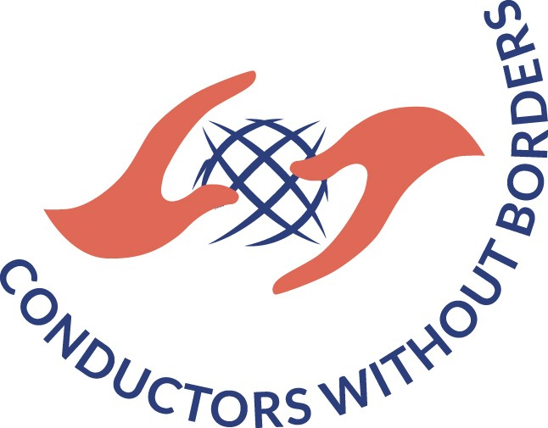

If you want to become one of the conductors/mentors/teachers of International Federation for Choral Music (IFCM) project Conductors Without Borders, please fill up this application form and send it to office@ifcm.net. Following the reception of your mail, one of IFCM team members will contact you for more details.

1. Personal data
Full name
Date of birth | dd/mm/yy
Address
City, State
Telephone number
E-mail
Occupation
Education
Which language do you speak? Please specify your level of knowledge
English
Beginner
Elementary
Intermediate
French
Beginner
Elementary
Intermediate
Spanish
Beginner
Elementary
Intermediate
Other languages

Are you currently conducting choir(s)? If yes, please name the choir(s)

Short biography (up to 200 words)

2. Interest in project
In which field can you contribute to the project? (Type of choir: male, female, children, mixed…; repertoire; music theory; management…)

Where did you hear about Conductors Without Borders? Please specify.

Did you participate in any other project/seminar/workshop where you were one of the leaders/mentors on project?
Yes
No

If yes, please name the project(s) and exact dates.

If you have any further details, please indicate them (up to 50 words)

Do have any experience in mentorship? If yes, please describe and specify.

